Monopolistic Competition Graph Conditions:

Short run Conditions:

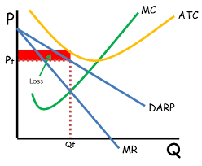
(Earning Profits): (Taking Losses)
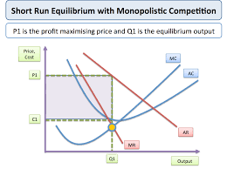

(Long Run Equilibrium) – cannot experience abnormal profits or losses

