- Assume that popcorn and movie attendance are complements and that Salty Concession grows corn suitable for popping. Mr. Concession will most likely sell a greater quantity of popping corn at a higher price if which of the following occurs?

  - The wages of farm workers and movie theater employees increase.
  - A technological improvement results in less expensive and more efficient harvesting of corn.
  - The introduction of new fat-free potato chips provides new competition in the snack-food market.
  - The release of three summer movies sets records for movie attendance.
  - New government regulations force movie theaters to hire more security guards at each theater.

- If bologna is an inferior good, which of the following must be true?

  - The demand curve for bologna is vertical.
  - The demand curve for bologna is horizontal.
  - An increase in the price of bologna will decrease the supply of bologna.
  - An increase in consumer income will decrease the demand for bologna.
  - A decrease in consumer income will decrease the supply of bologna.

- Which of the following events will cause the demand curve for hamburgers to shift to the right?

  - An increase in the price of pizza, a substitute for hamburgers
  - An increase in the price of french fries, a complement to hamburgers
  - An increase in the price of hamburgers
  - A decrease in the price of hamburgers
  - A decrease in the cost of producing hamburgers

- If a normal good is produced in a competitive market, which of the following combinations of events could cause the price of the good to increase and the quantity to decrease?

  - An increase in the average income of consumers and an increase in the number of producing firms
  - An increase in the average income of consumers and an increase in the price of a variable input
  - An increase in the price of a substitute good and an increase in the number of producing firms
  - A decrease in the number of consumers and a decrease in the price of a variable input
  - A decrease in the average income of con- sumers and an increase in the number of producing firms

- All of the following are included in computing the opportunity cost of attending college EXCEPT

  - interest paid on student loans
  - wages the student gave up to attend college
  - money spent on college tuition
  - money spent on clothing expenses
  - money spent on books and supplies

- A country can consume beyond its present production possibilities curve when it
  - trades with other countries, thus taking advantage of different opportunity costs
  - reduces unemployment, thus increasing output
  - experiences decreasing opportunity costs
  - faces an upward-sloping production possibilities curve
  - faces a downward-sloping production possibilities curve

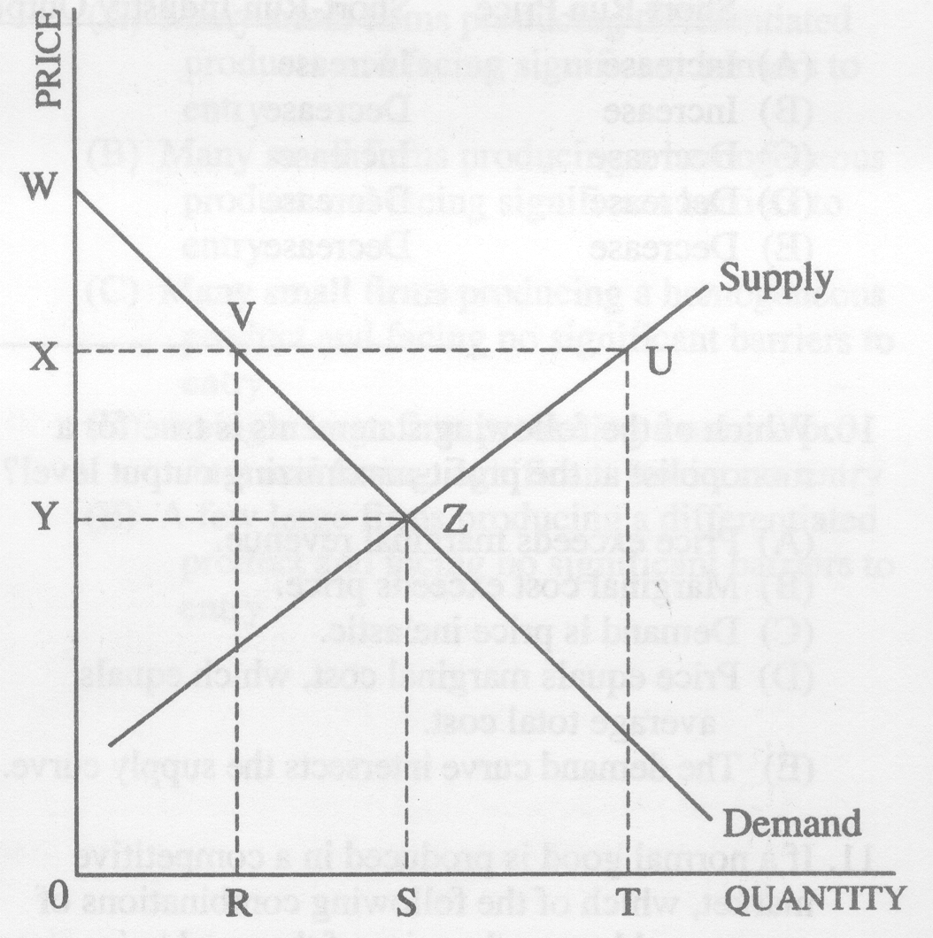
7 If a price floor is set at X, the quantity demanded will

  - increase from OR to OS
  - increase from OR to OT
  - decrease from OS to OR
  - decrease from OT to OR
  - not change

- The demand curve for a normal good slopes down for which of the following reasons?

- An increase in the price of the good induces consumers to purchase substitute products.
- An increase in the price of the good reduces consumers' purchasing power.
- An increase in the price of the good increases consumers' utility from consuming that good.

- I Only
- II Only
- III Only
- I and II only
- I and III only

9. The chart below shows the number of resource units the countries Gamma and Omega must use to produce one unit of food or one unit of clothing.

Gamma Omega

Food 10 resource units 5 resource units
Clothing 9 resource units 3 resource units
Which of the following statements is true according to the chart above?

- Trade should take place, with Gamma specializing in clothing production and Omega specializing in food production.
- Trade should take place, with Gamma specializing in food production and Omega specializing in clothing production.
- Each country should devote half of its resources to food production and half to clothing production and not trade.
- Since Omega can produce both food and clothing using fewer resources than Gamma, it cannot benefit from trade with Gamma.
- Since Gamma can produce both food and clothing using fewer resources than Omega, it cannot benefit from trade with Omega.
10. The table below represents points on an economy's current production possibilities curve.

Good X Good Y
1,000 0
990 100
980 200
970 300

The opportunity cost of increasing the production of good Y from 0 to 200 is

- 1,000 units of X
- 980 units of X
- 200 units of X
- 20 units of X
- 5 units of X

11. Which of the following situations best illustrates the law of demand?

- As real incomes of United States citizens have decreased over the past year, the demand for housing has also decreased.
- Recent decreases in the price of imported wine have led to an increase in the consumption of domestic wine.
- In the past several months, as the price of compact disc players has decreased, the quantity of compact disc players sold has increased.
- The increase in the price of quality health foods has increased the revenues of firms producing these goods.
- As the demand for computers has increased, the number of workers in the computer industry has increased.

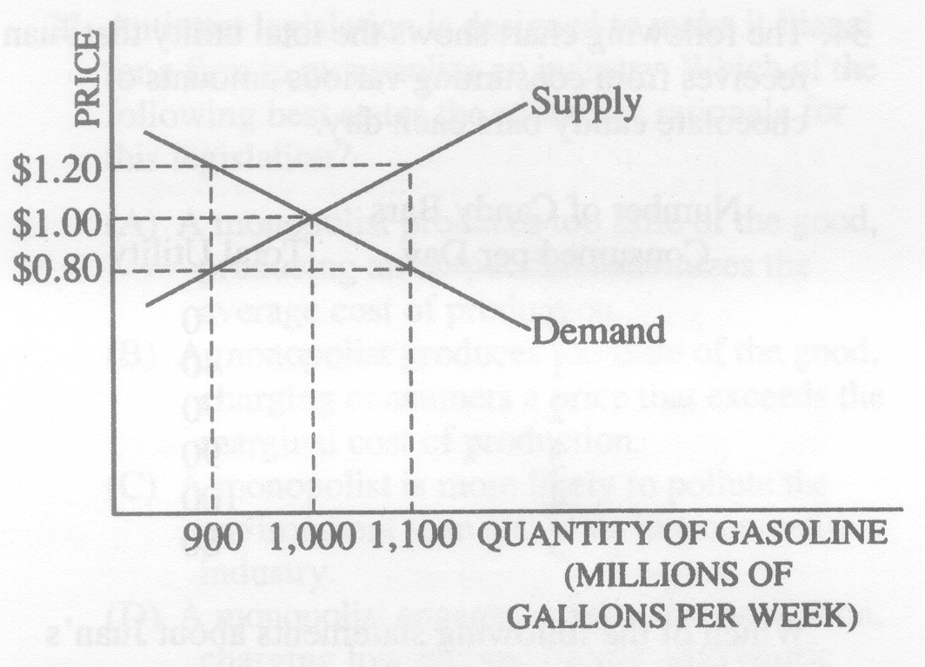
12. The graph above shows the supply and demand curves for gasoline. Which of the following will occur if the government establishes a price ceiling of $1.20 per gallon?

  - A shortage of 900 million gallons
  - A shortage of 200 million gallons
  - A shortage of 100 million gallons
  - A surplus of 100 million gallons
  - Neither a surplus nor a shortage

13. Following a decrease in the supply of oranges, the price of orange juice increased by 20 percent, which resulted in a 10 percent increase in the quantity of apple juice consumed. This implies that the cross elasticity of demand between orange juice and apple juice is
(A) 0
(B) 0.5
(C) 1
(D) 2
(E) indeterminate

14. Assume that apple juice and grape juice are substitutes. Which of the following will cause an increase in the quantity of apple juice supplied?
(A) A decrease in subsidies to apple juice producers
(B) A decrease in the price of grape juice
(C) An increase in the price of apple juice
(D) An increase in the price of insecticides used on apple trees
(E) The imposition of a price ceiling in the market for apple juice

15. Economists compute the price elasticity of demand as the
a. percentage change in price divided by the percentage change in quantity demanded.
b. change in quantity demanded divided by the change in the price.
c. percentage change in quantity demanded divided by the percentage change in price.
d. percentage change in quantity demanded divided by the percentage change in income.

16. For which of the following goods is demand probably most inelastic?
a. camcorders
b. insulin
c. apples
d. devices that remove cores from apples

17. If a 6 percent increase in income results in a 10 percent increase in the quantity demanded of pizza, then the income elasticity of demand for pizza is
a. negative and therefore pizza is an normal good.
b. negative and therefore pizza is a inferior good.
c. positive and therefore pizza is an inferior good.
d. positive and therefore pizza is a normal good.

18. Which of the following expressions represents a cross-price elasticity of demand?
a. percentage change in quantity demanded of apples divided by percentage change in quantity supplied of apples
b. percentage change in quantity demanded of apples divided by percentage change in price of pears
c. percentage change in price of apples divided by percentage change in quantity demanded of apples
d. percentage change in quantity demanded of apples divided by percentage change in income

19 Suppose the cross-price elasticity of demand between hot dogs and mustard is -2.00. This implies that a 20 percent increase in the price of hot dogs will cause the quantity of mustard purchased to
a. fall by 200 percent.
b. fall by 40 percent.
c. rise by 200 percent.
d. rise by 40 percent.

20. If the cross-price elasticity of two goods is – 1.75, then those two goods are
a. elastic and substitute goods
b. elastic and complementary goods.
c. inelastic and substitute goods.
d. inelastic and complementary goods.

