Directions: For the following graph below, use the letters in the graph and labels on axis to indicate either the area or point of the economic concept asked in the question:

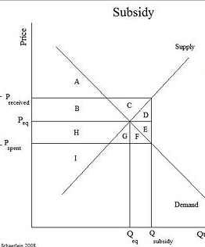

- The original price of the product before the subsidy. _________________________________
- The Original quantity of the product before the subsidy. _____________________________
- The area of the original consumer surplus before the subsidy. ______________________
- The area of the original producer surplus before the subsidy. _______________________
- The area representing the total dollar value of the subsidy. __________________________
- The area representing the producer benefit from the subsidy. _______________________
- The area of deadweight loss caused by the subsidy. _______________________________
- The new price consumers pay after it is subsidized. ______________________________
- The area of consumer surplus AFTER the subsidy is added ______________________
- Is the subsidy efficient for the market? (yes or no) ______________

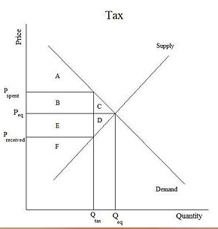

- The original price of the product before the tax. _________________________________
- The original quantity of the product before the tax. _____________________________
- The area of the original consumer surplus before the tax. ______________________
- The area of the original producer surplus before the tax. _______________________
- The area representing the total revenue collected by government from tax. ___________________
- The area representing the producer burden from the tax. _______________________
- The area of deadweight loss caused by the tax. _______________________________
- The new price consumers pay after it is taxed. ______________________________
- The area of producer surplus AFTER the tax is added ______________________
- Is the tax efficient for the market? (yes or no) ______________

- Assume the market for Good X is relatively (but not perfectly) elastic in demand only and a per unit sales tax is added to Good X.

- Graph the market for Good X correctly and clearly. Label the following:
- The original price Pe and quantity Qe
- The new price consumers pay with the tax Pcon
- The new price producers keep after paying tax Pp
- Do consumers pay more, less or equal tax burden as consumers? Explain why.
- Does producer surplus with the tax increase, decrease or remain the same?

